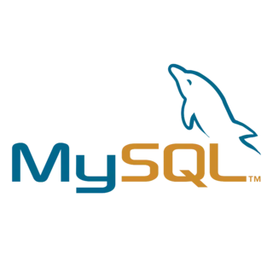***Apache, MySQL, php and phpmyadmin Installation tutorial***

***Jorge Arcoya López 2ºYear of DAW Bil***

Index

***Introduction 3***

***Installation 3***

***Web server status check 10***

***Grant permissions to be able to manage databases 11***

***Bibliografía 15***

Introduction

In the world of web development, a robust server environment is essential for building dynamic applications and managing databases efficiently. In this tutorial I will explain how to install Apache, PHP, MySQL and phpMyAdmin on Ubuntu and give it permissions to create databases.

Apache is one of the most widely used web servers in the world, offering great flexibility and ease of use. PHP is a server-side programming language that allows you to create interactive and dynamic web applications. MySQL is a relational database management system that integrates seamlessly with PHP, and phpMyAdmin is a web tool that simplifies MySQL database administration through an intuitive graphical interface.

Installation

The first thing to do before installing some of these servers and services is to update the packages.

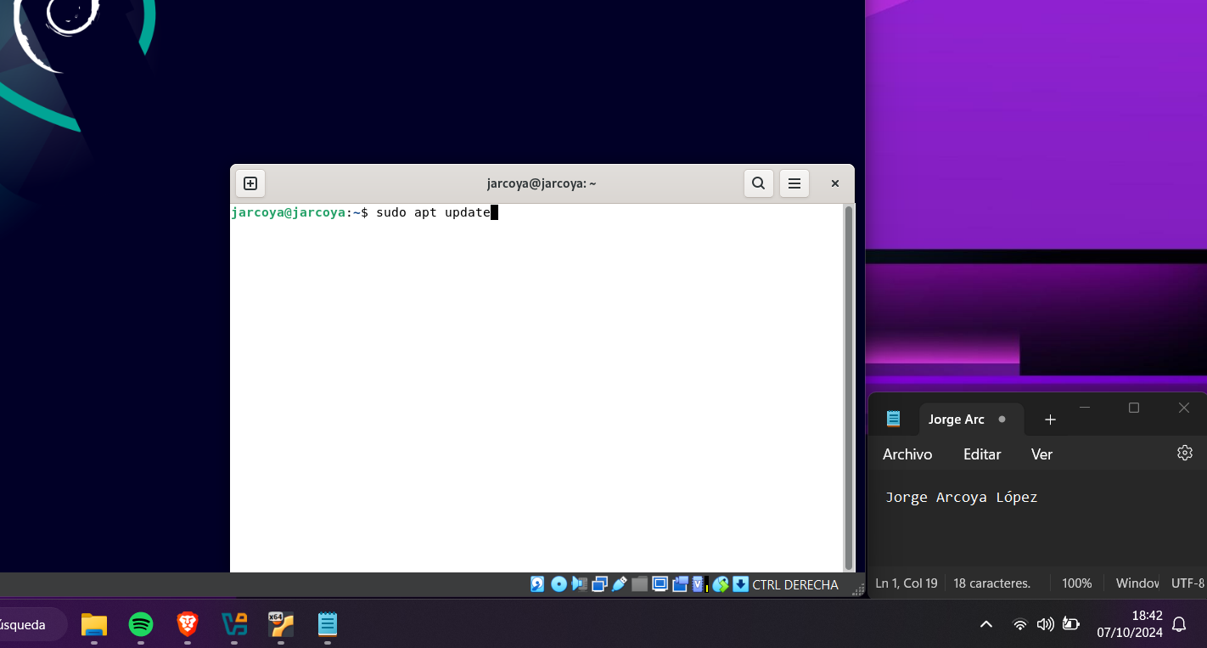The first thing to do is to run the command “sudo apt update” in the Ubuntu terminal, as shown in image 1.

Picture 1 Actualizar paquetes

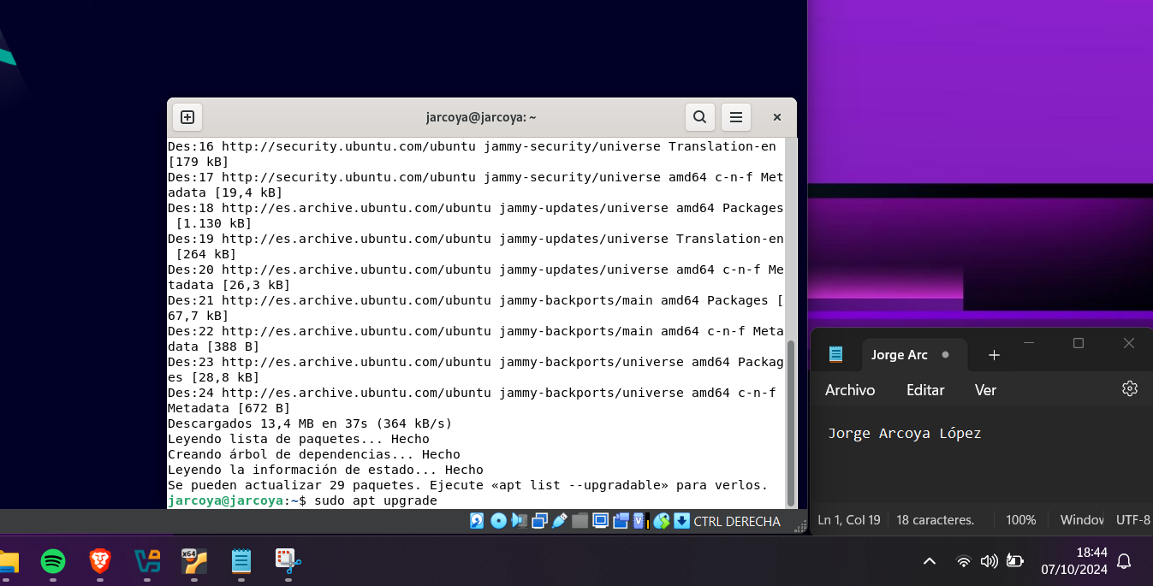After doing the update you have to execute the command “sudo apt upgrade”, image 2 shows how.

Picture 2 Actualizar paquetes

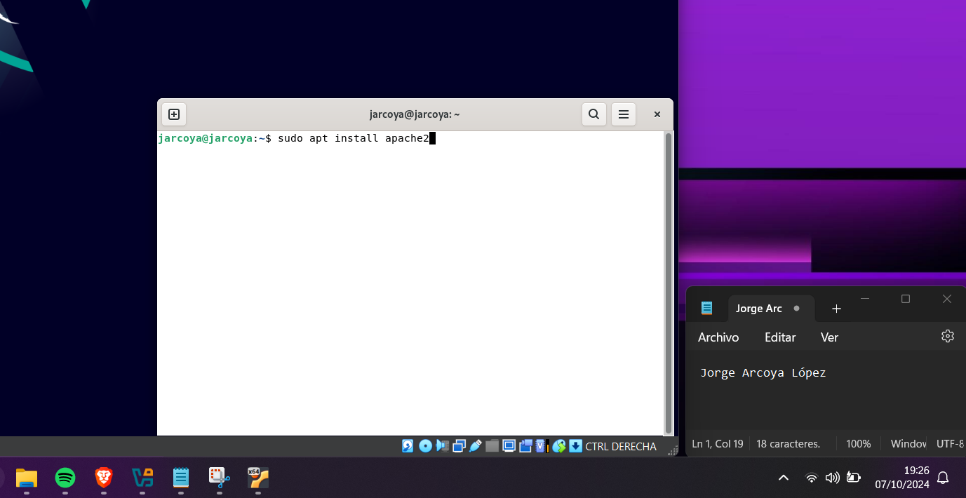Once the packages have been updated, you can start installing the services and servers, the first one I am going to install is apache, for this you have to use the command “sudo apt install apache2”, image 3 shows you how to do it.

Picture 3 Apache Installation

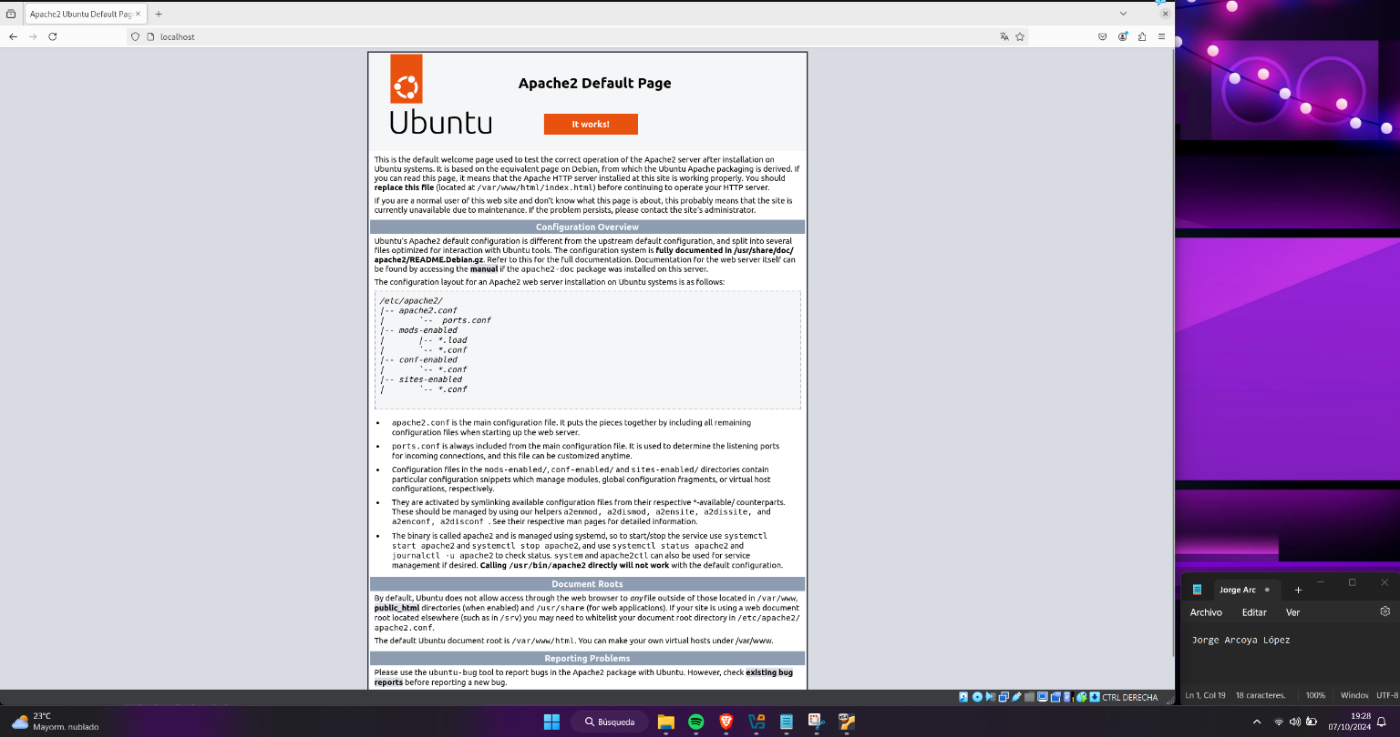After apache has finished installing, to check that it has been installed, go to a browser and enter “http://localhost” in the search bar, as shown in image 4.

Picture 4 Apache Check

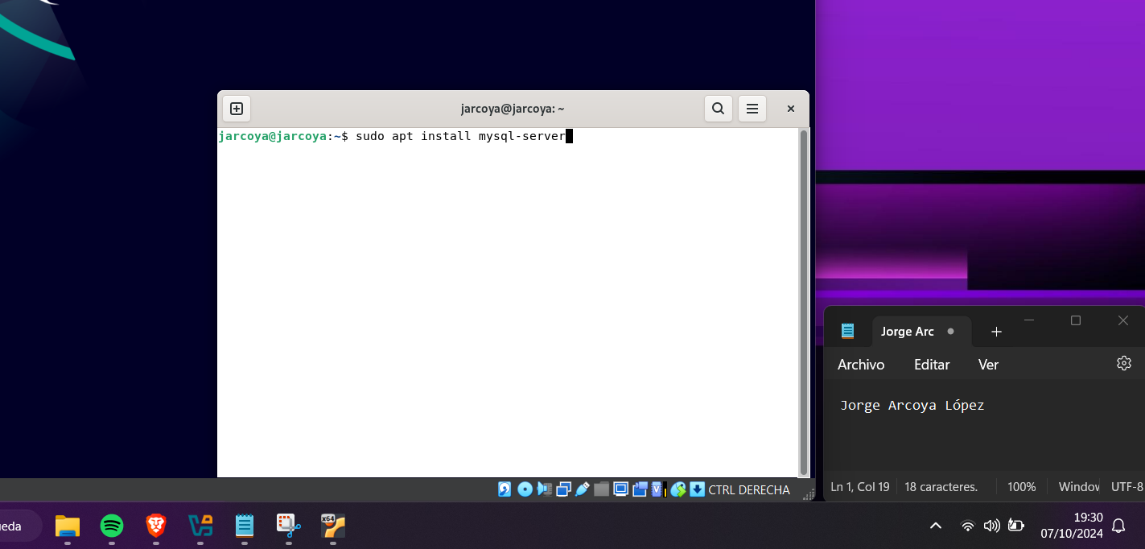Once I have checked that Apache has been installed and is working fine, I am going to install mysql, to do this you have to put the command “sudo apt install mysql-server” in the terminal, image 5 shows you how.

Picture 5 MySQL Installation

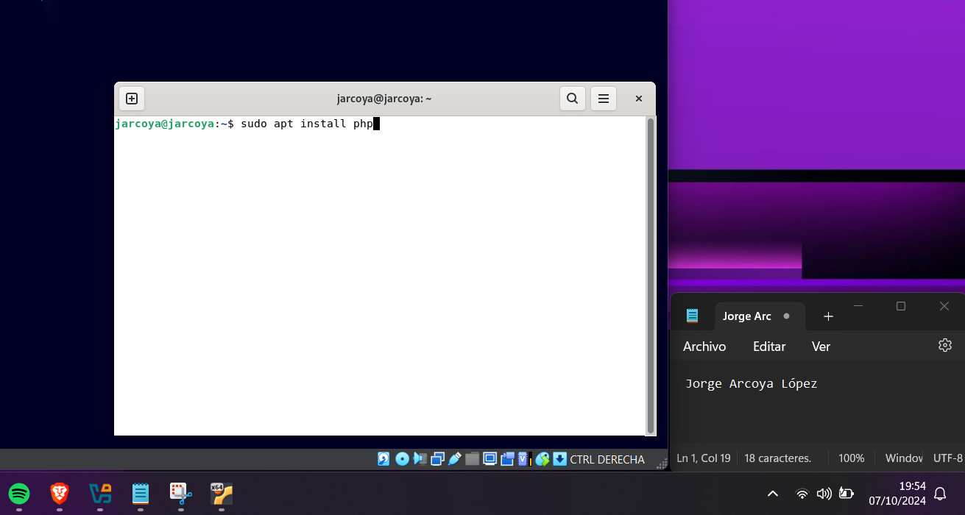When the mysql installation is finished I will install php, to do this just type “sudo apt install php” as shown in figure 6.

Picture 6 PHP Installation

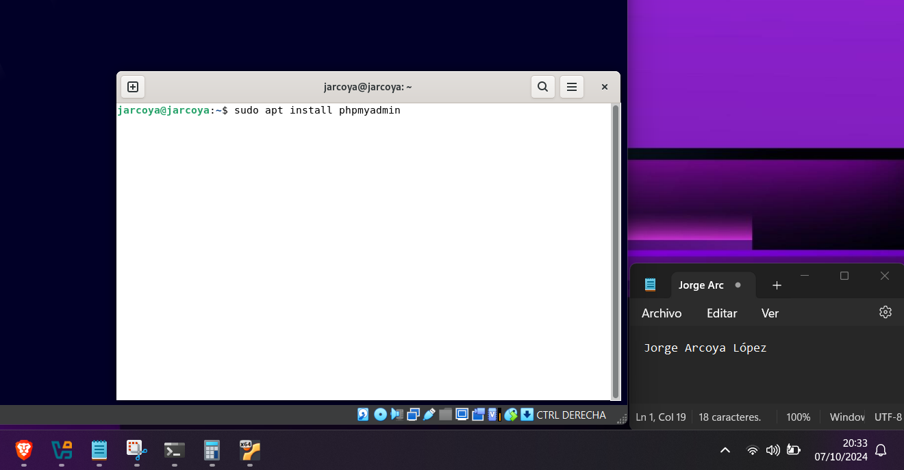The only thing left to do is to install phpmyadmin, using the command “sudo apt install phpmyadmin” as shown in screenshot 7.

Picture 7 PhpMyAdmin Installation

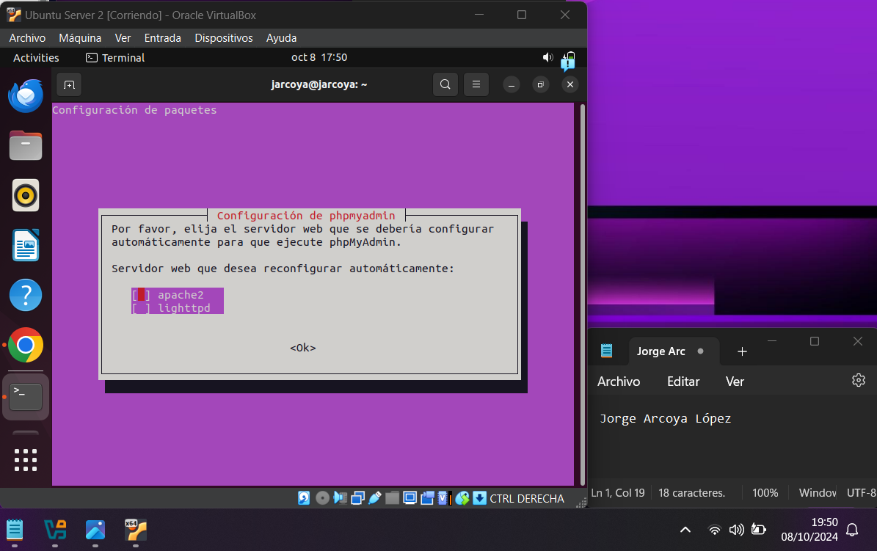During the installation of phpmyadmin it asks you to choose the web server that will be configured automatically, for that you have to choose the option of apache, as we have installed it before and click “ok”, as shown in the image 8.

Picture 8 Select web server

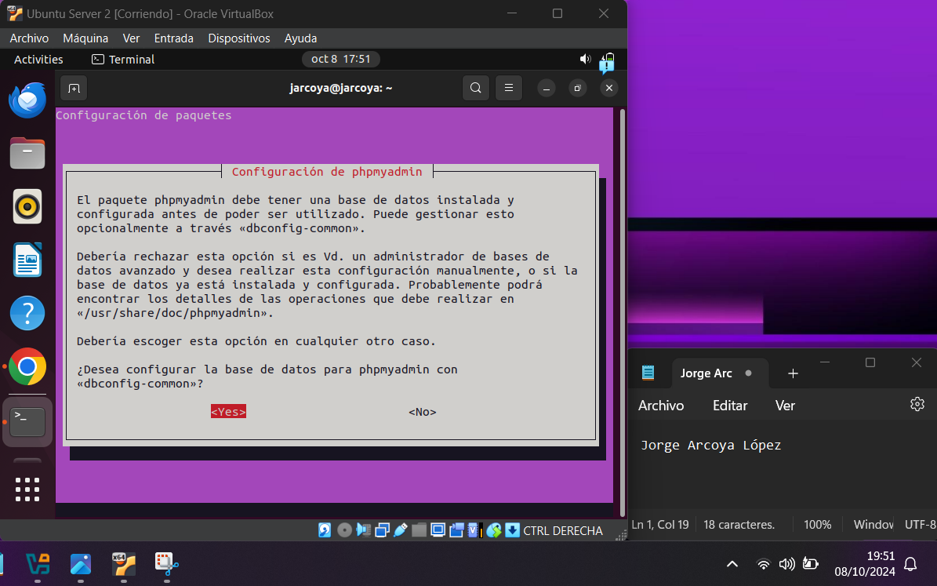After that you will be asked if you want to configure the database for phpmyadmin with “dbconfig-common”, choose “yes” in this part, otherwise you will have to configure the database manually, figure 9 shows you how to do it.

Picture 9 Date Base configure

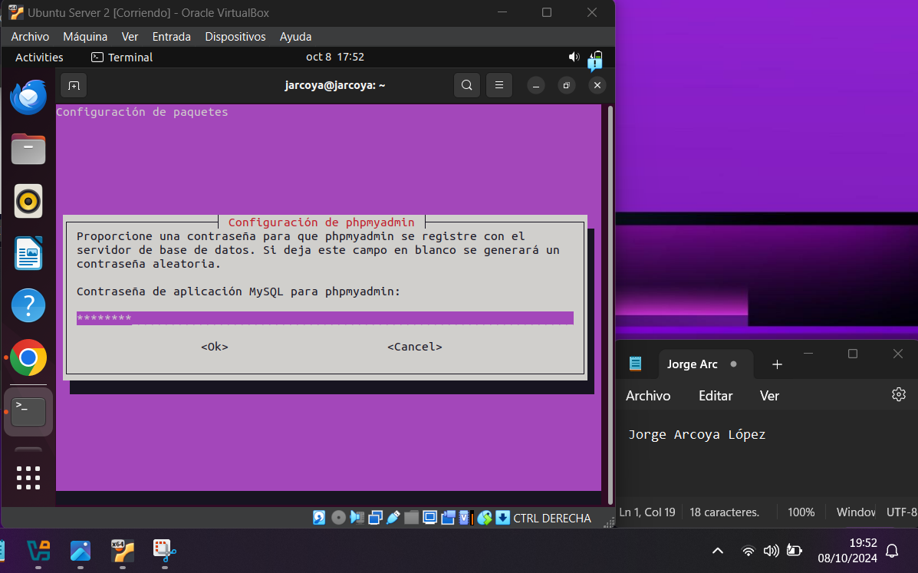To finish you just have to choose the password, confirm the password and click “ok”, image 10 shows how you have to do it.

Picture 10 Password and Finish of Installation of phpMyAdmin

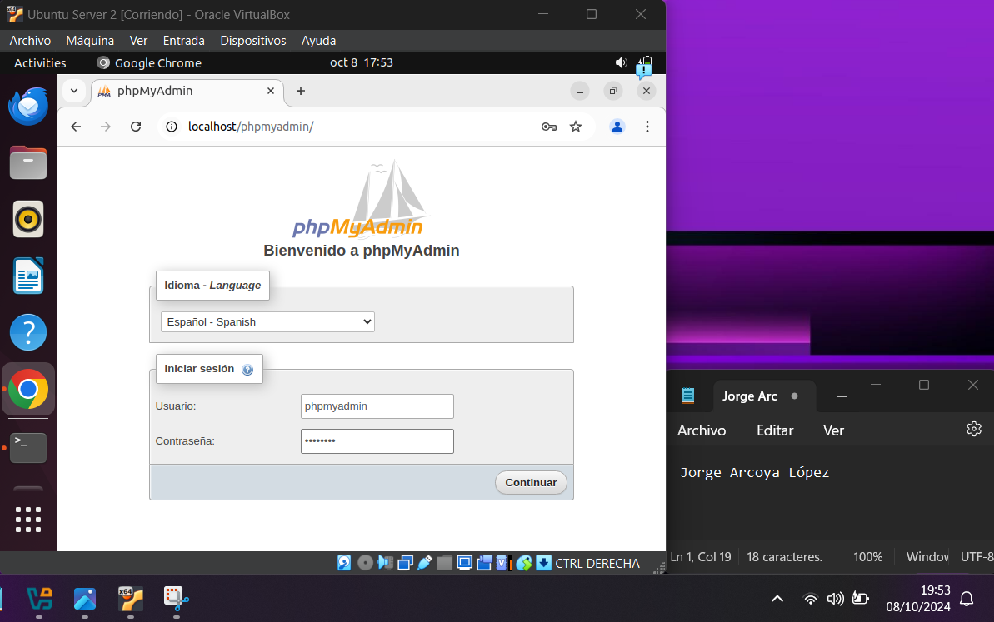To check this, go to the browser and look for “http://localhost/phpmyadmin” in the browser, as shown in image 11.

Picture 11 PHPMyAdmin

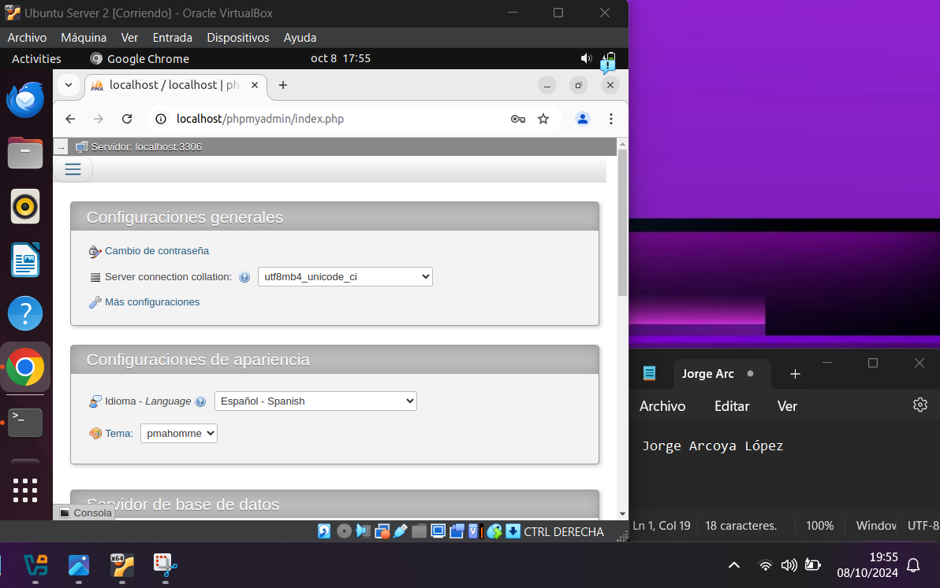Once there, enter the username which is “phpmyadmin” and the password you have chosen and when you log in you can see that everything has been installed correctly, Figure 12 shows you the result.

Picture 12 Installation Check

Web server status check

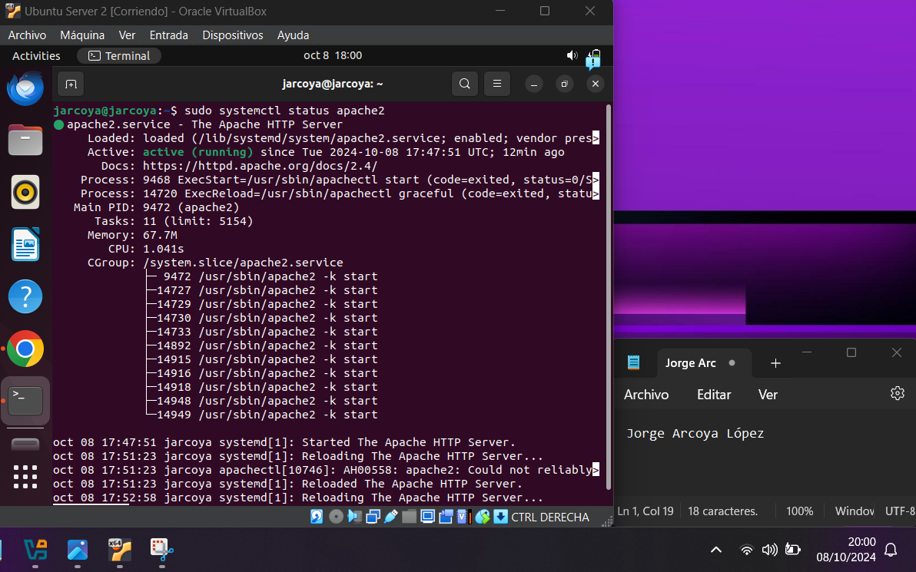To check the status of the web server we have just installed, just go to the Ubuntu terminal and enter the command “sudo systemctl status apache2”, image 13 shows the process and the result.

Picture 13 Web server status check

Grant permissions to be able to manage databases

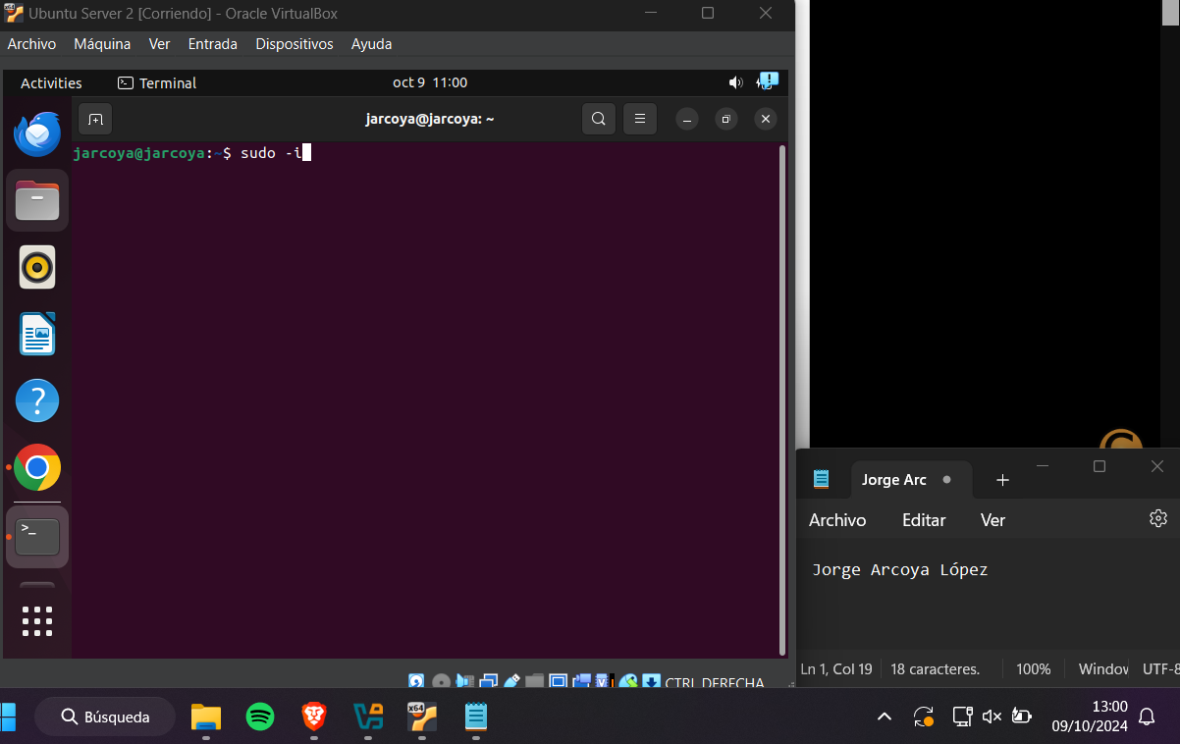And finally, you just have to create a user with permissions to be able to manage databases since the user created with the installation does not have permissions. To do this, you have to go to the terminal and first change to administrator by entering the command "sudo -i", image 14 shows how to do it.

Picture 14 sudo mode

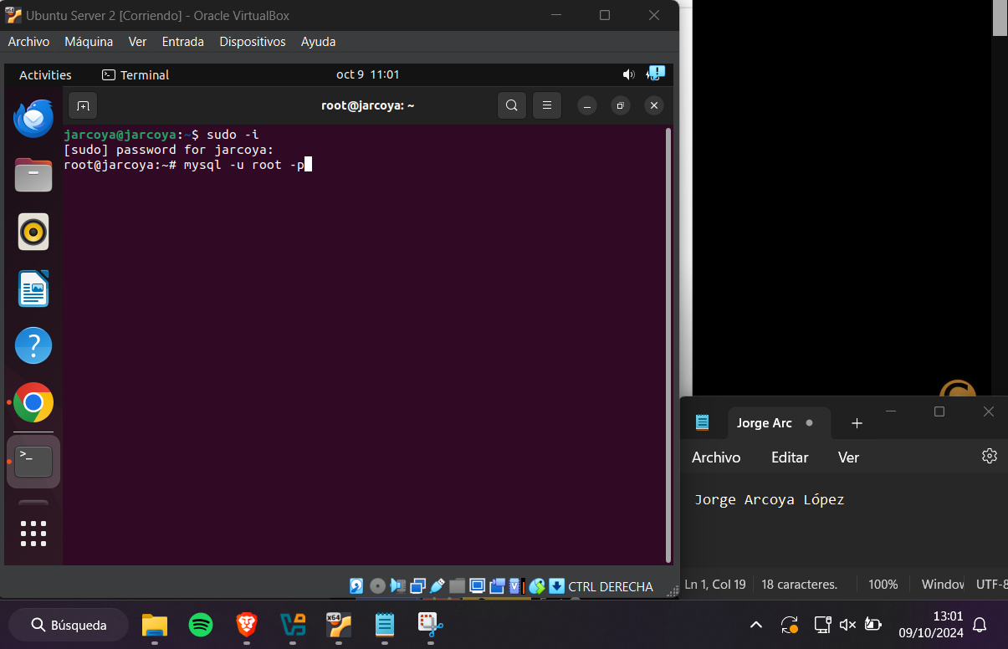Once you are set up as an administrator, you will need to enter the mysql menu as an administrator by typing "mysql -u root -p", Figure 15 shows how to do this.

Picture 15 mysql root mode

When you are in the MySQL root menu you have to create the user and to do this you have to enter the following command "create user 'username'@'%' identified by 'password';", image 16 shows you how.

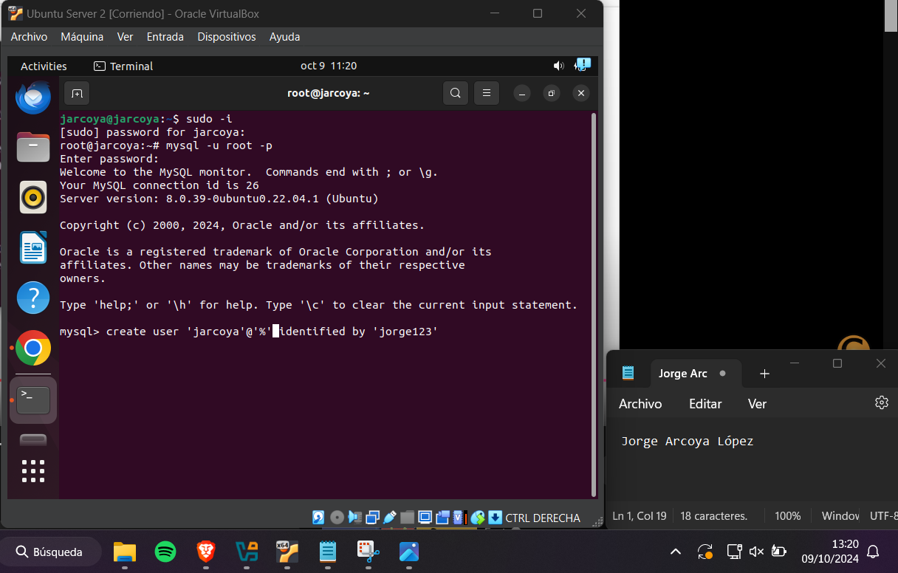

Picture 16 Create user

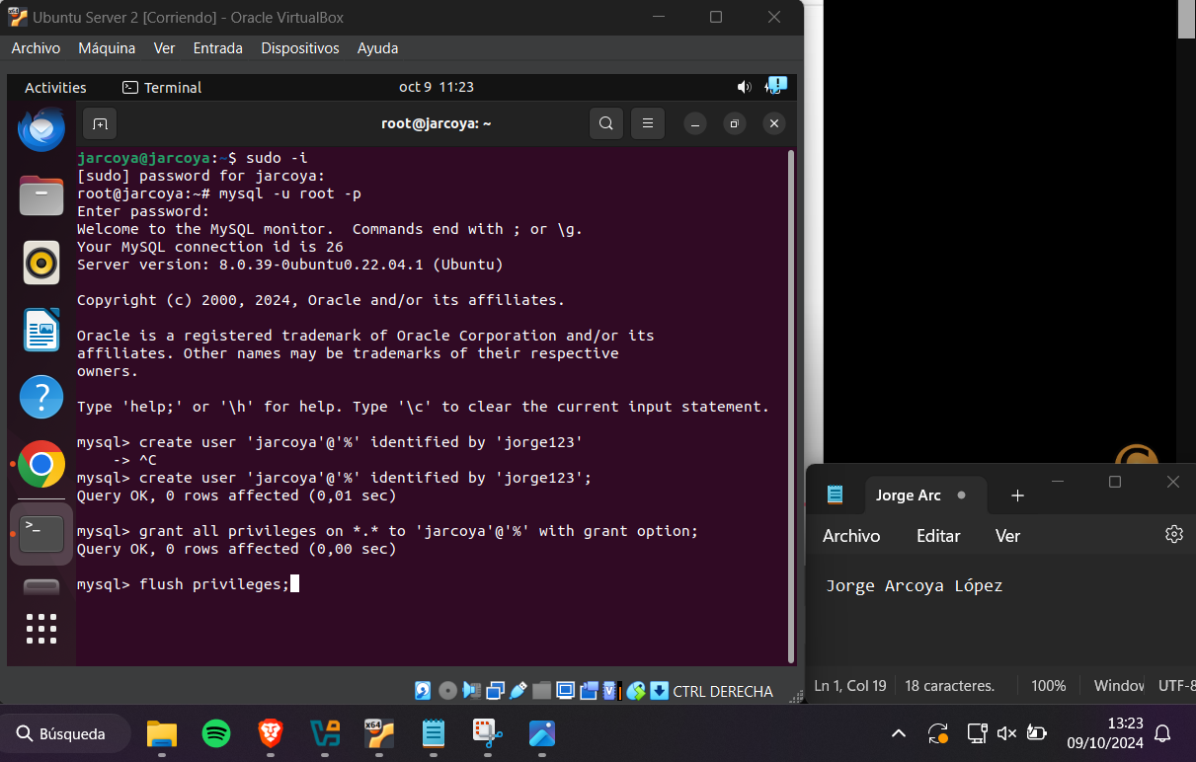Once the user has been created, you must give it the appropriate privileges. To do this, enter the following command: "grant all privileges on *.* to 'username'@'%' with grant option;", image 17 shows how to do this step.

Picture give privileges

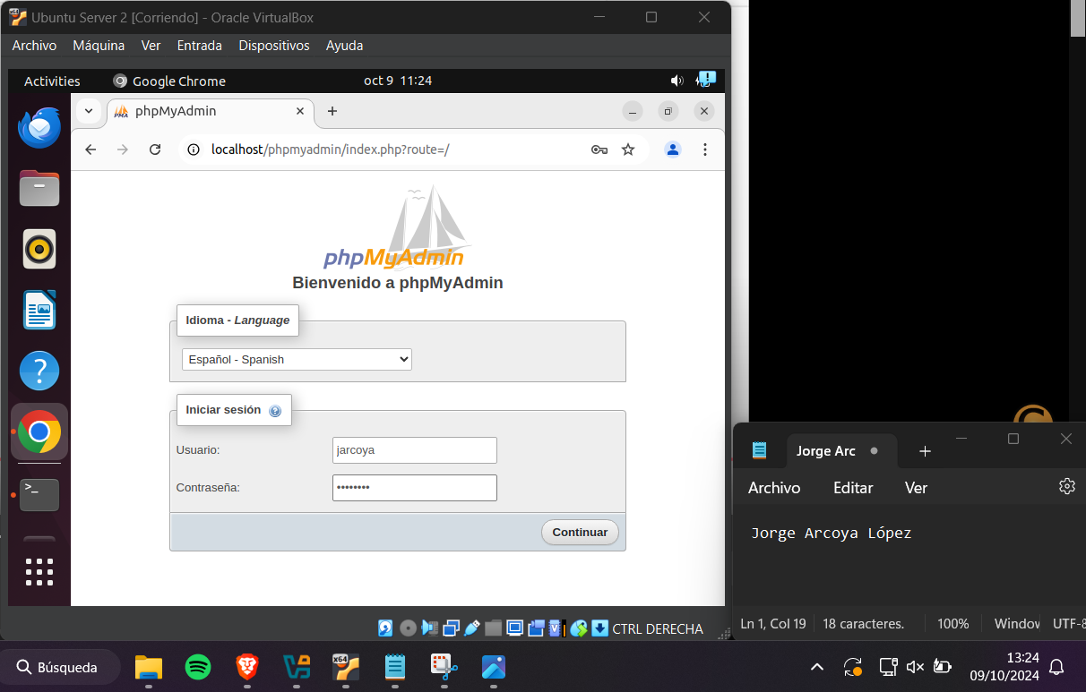After this, the only thing left is to enter phpmyadmin with the username and password that has been created, as shown in image 18.

Picture Enter to phpMyAdmin

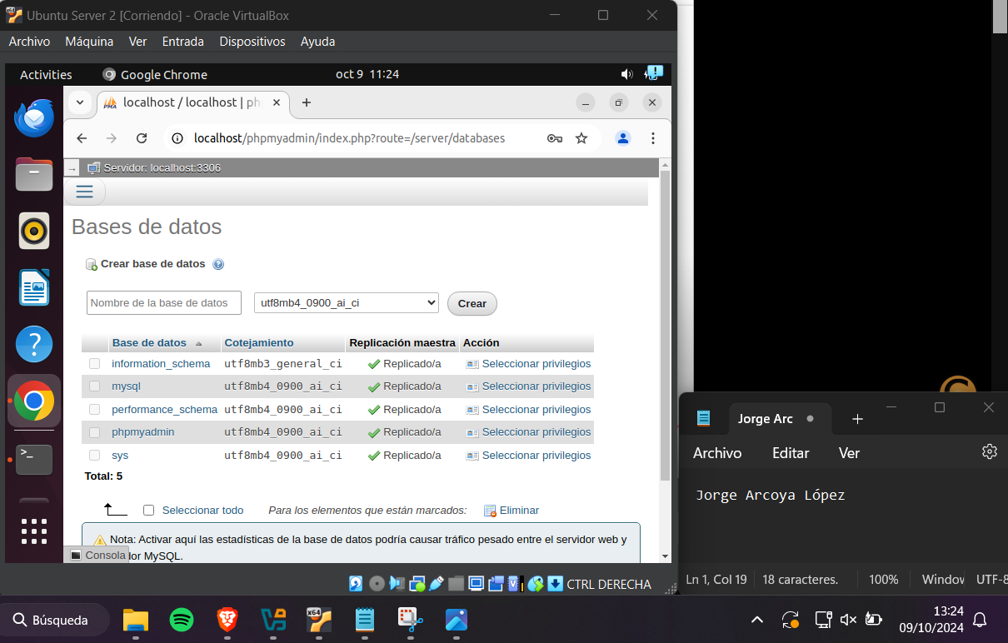And check that with this user you can create databases, as shown in image 19

Picture Check privileges

Bibliografía

Video instalación: <https://www.youtube.com/watch?v=yxiOaaiE_QY>